1. Kmeans

6. What do you observe about the dependence of the final cluster quality on the number of clusters K used? [1/2 mark]

K value | Distance between the clusters
2 | 83.5
3 | 62.8
4 | 58.1
5 | 50.1

The final cluster distance decreases as the k value increases.

6. Find a seed that gives you a cluster quality of 62.8 or better. [½ mark]

rng(10);
K = 3;
Kmeans Finished: Final cluster quality: 63.0.

7. Has the clustering accuracy improved from before to after of the uncommenting above? Why? [1 mark]

X = meas(:,1:2); d = 2;
Kmeans Finished: Final cluster quality: 79.5
Best cluster accuracy found: 0.8

X = meas; d = 4;
Kmeans Finished: Final cluster quality: 79.5
Best cluster accuracy found: 0.9

At first, we used not all measurements, but only 2 of them. Then we used all and the accuracy level increased because we used all the columns in our dataset, more dimensions.

7. Cell four contains the inner content of an loop to compute TPR and FPR. Add the missing loop required to try a bunch of thresholds and fill in the TPR and FPR vectors. [1 mark]

NEW CODE BELOW:

%% Cell 4;
% This code computes the confusion matrix, and TPR/FPR for NB and LR/MaxEnt.
% Add a loop over threshold to try a whole bunch of thresholds, and plot fpr against tpr to generate an roc curve.
tpr_log = [];
fpr_log = [];
tpr_nai = [];
fpr_nai = [];

for thr = 0.0:0.1:1.0
%thr = 0.25;
predTr = pTrLR>thr; fprintf(1,'LR Train acc: %1.2f\n', sum(Ytr==predTr)/numel(Ytr));
predTe = pTeLR>thr; fprintf(1,'LR Test acc: %1.2f\n', sum(Yte==predTe)/numel(Yte));
cmat = confusionmat(Yte,double(predTe))
tpr_lr=cmat(2,2)/sum(Yte==1);
fpr_lr=cmat(1,2)/sum(Yte==0);

predTr = pTrNB(:,2)>thr; fprintf(1,'NB Train acc: %1.2f\n', sum(Ytr==predTr)/numel(Ytr));
predTe = pTeNB(:,2)>thr; fprintf(1,'NB Test acc: %1.2f\n', sum(Yte==predTe)/numel(Yte));
cmat = confusionmat(Yte,double(predTe))
tpr_nb=cmat(2,2)/sum(Yte==1);
fpr_nb=cmat(1,2)/sum(Yte==0);

tpr_log = [tpr_log, tpr_lr];
fpr_log = [fpr_log, fpr_lr];
tpr_nai = [tpr_nai, tpr_nb];
fpr_nai = [fpr_nai, fpr_nb];

end

8. Plot tpr (y-axis) against fpr (x-axis) to visualize the resulting ROC curve. [ 1 mark ]

NEW CODE BELOW:

plot(fpr_log, tpr_log);
hold on
plot(fpr_nai, tpr_nai);
legend('Logistic Regression','Naive Bayes','Location','Best')
xlabel('False positive rate');
ylabel('True positive rate');
title('ROC Curves for Logistic Regression and Naive Bayes Classification')
hold off

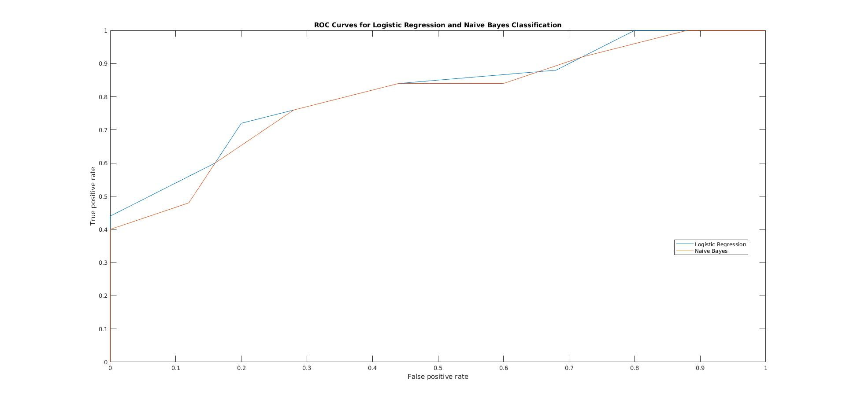
11. Which one is preferable by AUC metric? [1 mark]

aucLR = 0.8104
aucNB = 0.7992
Logistic Regression classification is more preferred, according to AUC value.

12. Suppose for a particular application, the maximum allowed FPR is 0.16.
Which classifier is preferable (obtains the maximum TPR given this FPR
constraint)? [1 mark]

Both are fine, because they have the same TPR = 0.6.

